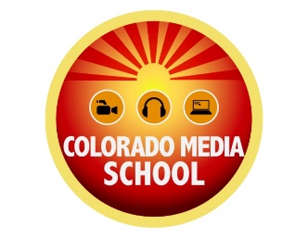
Gainful Employment Disclosures – 2019
Denver Campus

Program Name: Audio Production

This program is designed to be completed in 24 Weeks.

This program will cost $11,875 if completed within normal time. There may be additional costs for living expenses. These costs were accurate at the time of posting, but may have changed.

Of the students who completed this program within normal time, the typical graduate leaves with $0 of debt.
- Fewer than 10 students completed this program within normal time. This number has been withheld to preserve the confidentiality of the students

- The following States do not have licensure requirements for this profession: Colorado

For more information about graduation rates, loan repayment rates, and post-enrollment earnings about this institution and other postsecondary institutions please click here: https://collegescorecard.ed.gov/search/?name=Colorado%20Media%20School&sort=salary:desc

